# Lab1

## name: Zeng Yuhang

## ID: 222320008



my familiy tree:

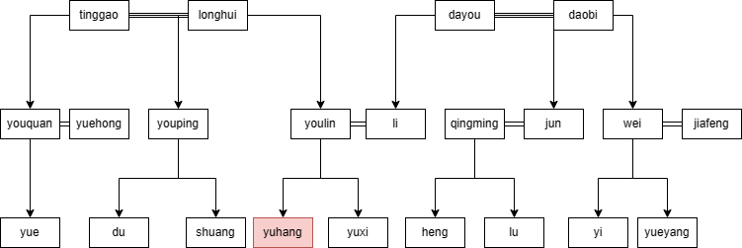

This is a simple version. The red one is me. = connects spouses. → connects parent and child.

The entire family tree knowledge shows below in text:

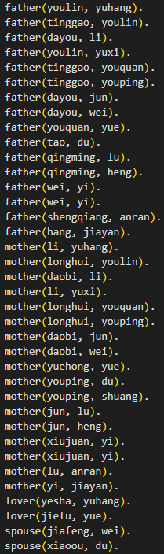

The rules I declare contain:

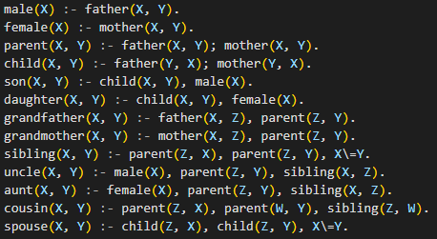

Then I test all above relations of me:

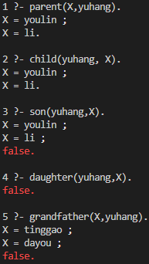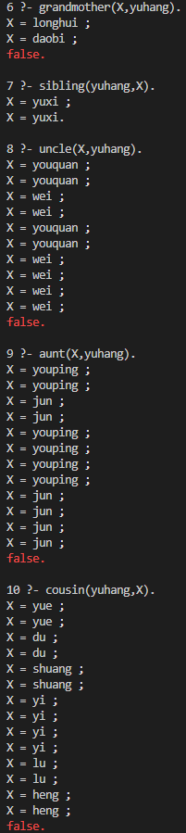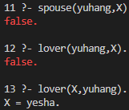

The main problem is when rules getting complex, there will be many redundant result inference from different logic lines. I have not found a solution right now.

Also, I forget to declare lover relation is reflexivity. Thus, question 12 and 13 return different results.